Hi, this document doesn’t have the script, it will be on a text document named; ‘**JitterAimRandomizerScript.txt**’.

This document is a guide on how you set up the script.

Follow the guide and it should work.

REQUIRMENT:

1. PC
2. Logitech G Hub Installed
3. Have ‘NumLock’ button available.

STEP 1:

Open ‘**JitterAimRandomizerScript.txt**’ file, select all the word by pressing ‘CTRL+A’, and copy it by pressing ‘CTRL+C’

STEP 2:

Open Logitech G Hub

STEP 3:

Click ‘Desktop: Default’ tab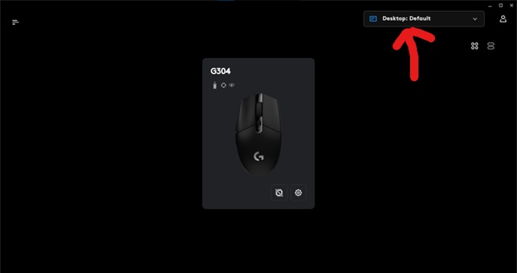

STEP 4:

Click ‘Manage Profiles’  
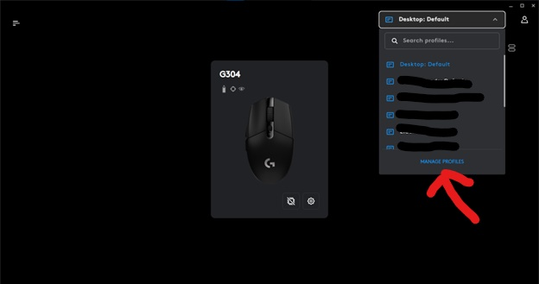

STEP 5:

Select the game you want to apply the script

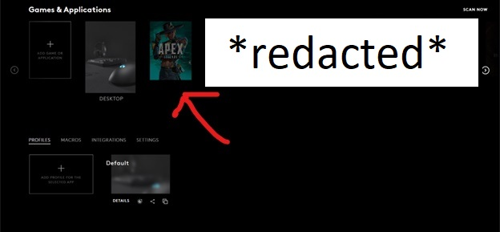

STEP 6:

Click ‘Scripting symbol’

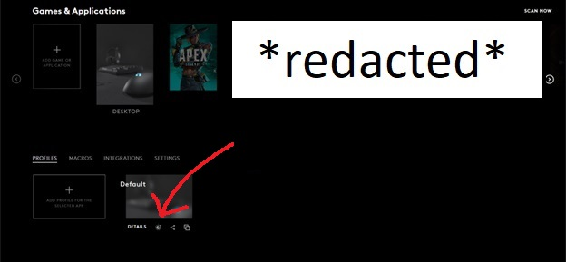

STEP 7:

Click ‘CREATE A NEW LUA SCRIPT’  
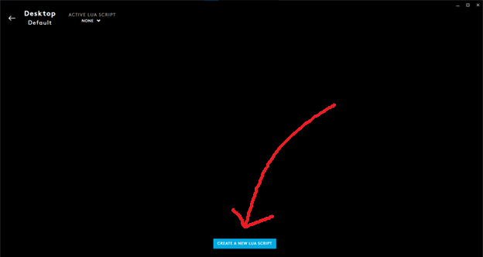

STEP 8:

Delete pre-existing code, paste the script code

STEP 9:

Click ‘Script’ tab

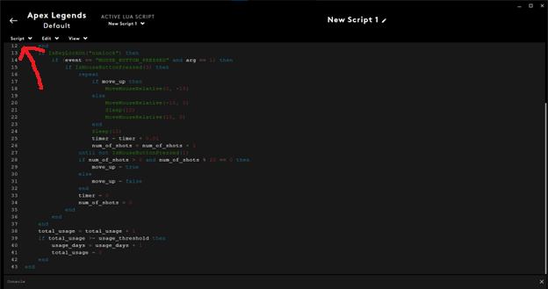

STEP 10:

Click ‘Save & Run’

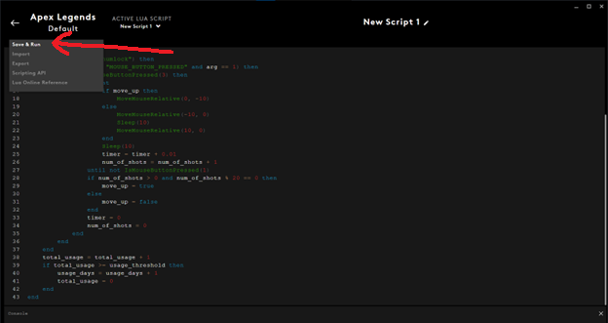

**SETUP DONE!**

To activate the script during game, make sure ‘NumLock’ is on. The jitter aim will be execute whenever left and right mouse button are pressed.

To understand how this code works and how it can avoid detection, read the ‘**ScriptExplanation**’ documents.